THE PRESIDENT’S OFFICE
REGIONAL ADMINISTRATION AND LOCAL GOVERNMENT
NAMANGA SECONDARY SCHOOL
FORM FOUR PRE-MOCK EXAMINATION
062 BOOK KEEPING
MARKING SCHEME APRIL 2025

SECTION A (15 Marks)
1.
(i) | (ii) | (iii) | (iv) | (v) | (vi) | (vii) | (viii) | (ix) | (x)
C | D | A | C | C | C | A | C | C | C
01 mark @ = 10 Marks
2.
COLUMN A | (i) | (ii) | (iii) | (iv) | (v)
COLUMN B | F | H | A | B | D
01 mark @ = 05marks

SECTION B (40 Marks)
3. (a)
Dr Motor van a/c Cr
2011

2011:

January

cash
–

01

18,000,000

December Balance c/d

33,000,000

O
ctober

Cash
–

02

15,000,000

33,000,000

33,000,000

2012

2012

January Balance b/d

33,000,000

December: Balance c/d

52,000,000

July Cash
–

03

19,000,000

52,000,000

52,000,000

2023:

January Balance b/d

52,000,000

Working for Depreciation
Year Assets
2011: 1st Motorvan: 18,000,000 x
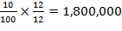
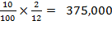
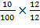
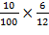
2nd Motorvan: 15,000,000 x

5
,
550
,
,000

=

1,800,000

=

1,500,000

=

950,000

2012: 1st Motorvan : 18,000,000 x
2nd motorvan : 15,000,000 x
3rd motorvan : 19,000,000 x
(b)
Dr |  | Provision for Depreciation a/c |  |  |  | Cr
2011:

2011:

December, balance c/d

5
,
550
,
,000

December Income statement

5
,
550
,
,000

2012

2012:

December balance c/d

9
.800,000

January balance b/d

5
,
550
,
,000

December Income statement

4,250,000

6,425,000

9
.800,000

2013:

January balance b/d

9
.800,000

20
ticks @ 0.5 mark = 10 marks

4.

Dr

ADJUSTED CA
SH BOOK

Cr

Balance b/d

27,400

320

Credit transfer (Machinga group)

201

Bank charges
Standing order (Mr Kiboleo)

980

Balance b/d

28,110

29,410

29410

Balance b/d

28,110

BANK RECONCILIATION STATEMENT AS AT 1ST MARCH, 2019
Bank balance as per adjusted cash book

28,110

Add:

Unpresented cheques

Mr. Simba

1,310

29,420

Less:

Uncredited cheque

(
Banking

not yet in bank statement)

4,100

Balance as per bank statement

25,320

10
ticks @ 1 ma
rk = 10 marks

- APPROPRIATION STATEMENT FOR THE YEAR ENDED 31/12/2005
Net profit during the year ………………………..

184,800

Add:

Interest on drawings:

Milembe ………………………………

1200

Madete ………………………………..

900

Minza ………………………………….

500

2,600

Less
:

Interest on capital:

187
,
4
00

Milembe ……………………………….

3,600

Madete …………………………………

2,700

Minza …………………………………..

2,100

Salaries:

Madete ………………………………….

22,000

Minza ……………………………………

28,000

,
(58
4
00)

129,000

Share of profit:

Milembe
% ……………………………
55

70,950

Madete 25% ……………………………..

32,250

Minza 20% ………………………………

25,800

129,000

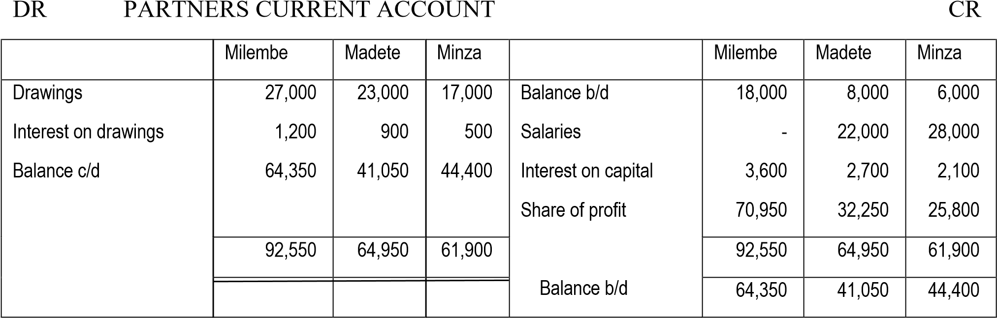

31 ticks @ 1/3 = 10 marks

- Del credere commission
Is an additional commission paid to an agent who guarantees the payment in case of credit sales. This commission is usually calculated as a percentage of credit sales.
- Consignee
Is a person to whom the goods are sent for sale. The consignee is also known as agent.
- Bill of exchange
Refers to an order in writing drawn by one party and accepted by another requiring the latter to pay an amount. In consignment it shows an acknowledgment of debt by the consignee as a result of the goods sent to him for sale.
- Consignor
Refers to a person/business sending the goods to another person (consignee) for sale. The consignor is also known as principal party.
- Account sales
Is the document prepared by consignee and sent to the consignor showing transactions made by him (consignee). Such transactions includes; sales, expenses and commission. 5 sticks @ marks = 10 marks

SECTION C (45 Marks)
- (a) JOURNAL ENTRIES
S/N |  | DR |  | CR
(i) | Purchases a/c  Suspense a/c |  | 10,000 |  | 10,000
(ii) | Suspense a/c  Maimuna a/c |  | 3,900 |  | 3,900
(iii) | Motor repairs a/c  Suspense a/c |  | 7,600 |  | 7,600
(iv) | Returns outwards a/c  Motor vans a/c |  | 5,000 |  | 5,000
(v) | Daima account  Purchases a/c  Sales a/c |  | 8,000 |  | 4,000  4,000
(vi) | Office equipment a/c  Mikocheni traders a/c  Suspense a/c |  | 3,500  1,800 |  | 5,300
(vii) | Returns inwards a/c  Returns outwards a/c  Suspense a/c |  | 7,500  7,500 |  | 15,000

SUSPENSE A/C
Dr Dr
Difference as per Trial balance

,
26
1
00

Purchases

10,000

Maimuna

3,900

Returns outwards

5,000

Returns inwards

7,500

Returns outwards

7,500

30,000

30,000

(c) STATEMENT OF CORRECTED NET PROFIT AS AT 31ST DEC, 2020
Reported unadjusted net profit

8,400

Add: (All errors reduced net profit):

Purchases …………………………………..

4,000

Sales ………………………………………..

4,000

Purchases …………………………………..

,300
13,300
5

21,700

Less: (A
ll errors increased net profit):

Purchases

10,000

Motor repairs

7,600

Returns outwards

5,000

Returns inwards

7,500

Returns outwards

7,5000

37,600

(15,900)

CORRECT NET LOSS

38 ticks @ 0.4 = 15 Marks
8. STATEMENT OF FINANCIAL POSITION AS AT 31ST MARCH, 2018
TZS

TZS

NON
-
CURRENT ASSETS:

Investment

500,000

Equipment

180,000

Less: Depreciation

30,000

150,000

Building

200,000

Less: Depreciation

10,000

190,000

CURRENT ASSETS:

Stock of m
edicines

75,000

Subscriptions outstanding

5,000

Bank

20,000

Cash

2,500

102,500

942,500

CURRENT LIABILITIES

Subscription received in advance

2,500

Creditors of medicines

60,000

(62,500)

NET ASSETS
Accumulated fund 847,500
Add: Surplus 32,500
TOTAL EQUITY 880,000

880,000

38 ticks @ 0.4 = 15 marks
INCOME AND EXPENDITURE STATEMENT FOR THE YEAR ENDED 31/03/2018
TZS TZS
Incomes:
Subscriptions 255,000
Donations 72,500
Interest on investment 35,000
Charity show profit = charity show receipt 50,000
Less: Charity show expenses 5,000 45,000
407,500
LESS Expenditure:
Medicines 145,000
Honorarium to doctors 50,000
Salaries 137,500
Sundry expenses 2,500
Depreciation
Equipment 30,000
Buildings 10,000 40,000 (375,000)
SURPLUS (Excess of incomer over expenditure 32,500

9.

WORKINGS:

DR

CASH ACCOUNT

CR

Balance b/d

194,000

Creditors

1,310,000

Cash sales

1,540
,000

Sundry expenses

180,000

Bank

12,600,000

Drawings

12,572,000

Balance c/d

272,000

14,334,000

14,334,000

Balance b/d

272,000

Cash drawings = (Total Dr – Total Cr) of cash account.
Total drawings = 12,572,000 + 11,400,000 =23,972,000
DR

Cash

Balance b/d

7,300,000

Bank

63,400,000

Purchases (credit)

65,510,000

Balance c/d 8,100,000
72,810,000 72,810,000

Balance b/d

8
,100,000

9.

DR

DEBTORS A/C

CR

Balance b/d

9,200,000

Bank

94,200,000

Sales

96,400,000

Balance c/d

11,400,000

105,600,000

105,600,000

Balance b/d

11,400,000

Total sale

=

Credit sales + cash sales

=

96
,400,000 +
1,540,000

= 97,940,000
INSURANCE A/C

Balance b/d

340,000

Income statement

1,840,000

Bank

1,900,000

Balance c/d

400,000

2,240,000

2,240,000

Balance b/d

400,000

JOURNAL ENTRY

S/N

DETAILS

Folio

DR

CR

ASSETS:

Cash

Bank

Stock

Debtors

Insurance prepaid

Motor van

LIABILITIES:

Creditors

CAPITAL (Assets
–

liabilities)

194,000

920,000

24,200,000

920,000

340,000

5,500,000

40,354,000

7,300,000

33,054,000

40,354,000

9. INCOME STATEMENT FOR THE YEAR ENDED 31ST DECEMBER, 2018

TZS

TZS

TZS

Sales

97,940,000

Less: COST OF GOODS SOLD

Opening stock

24,200,000

Add: Purchases

65,510,000

Cost of goods available for sale

89,710,000

Less: Closing stock

27
,100,
000

Cost of goods sold

62,610,000

62,610,000

Gross profit

35,330,000

LESS: EXPENSES:

S
undry
expenses

1000000

Rent

3,200,000

Add: Rent owing

360,000

3,560,000

Insurance

1,840,000

Depreciation on motorvan (5,500,000
-
4,600,000)

900,000

7,300,000

NET PROFIT

28,030,000

STATEMENT OF FINANCIAL POSITION AS AT 31ST DECEMBER 2018
NON-CURRENT ASSET  Motor van  Less: Depreciation  CURRENT ASSETS  Cash in hand  Cash at Bank  Debtors  Stock  Insurance  TOTAL ASSETS  Financed by Equity  Capital  Add: Net profit  Less: Drawings  CURRENT LIABILITIES  Creditors  Rent owing  NON-CURRENT LIABILITIES  Loan | 5,500,000  900,000  272,000  4,300,000  11,400,000  27,100,000  400,000  33,054,000  28,030,000  61,084,000  (23,972,000)  8,100,000  360,000 | 4,600,000  43,472,000  48,072,000  37,112,000  8,460,000  2,500,000  48,072,000

